**Lab - Encrypting and Decrypting Data using a Hacker Tool**

Part 1: Create and Encrypt Files

Step 1: Create text files

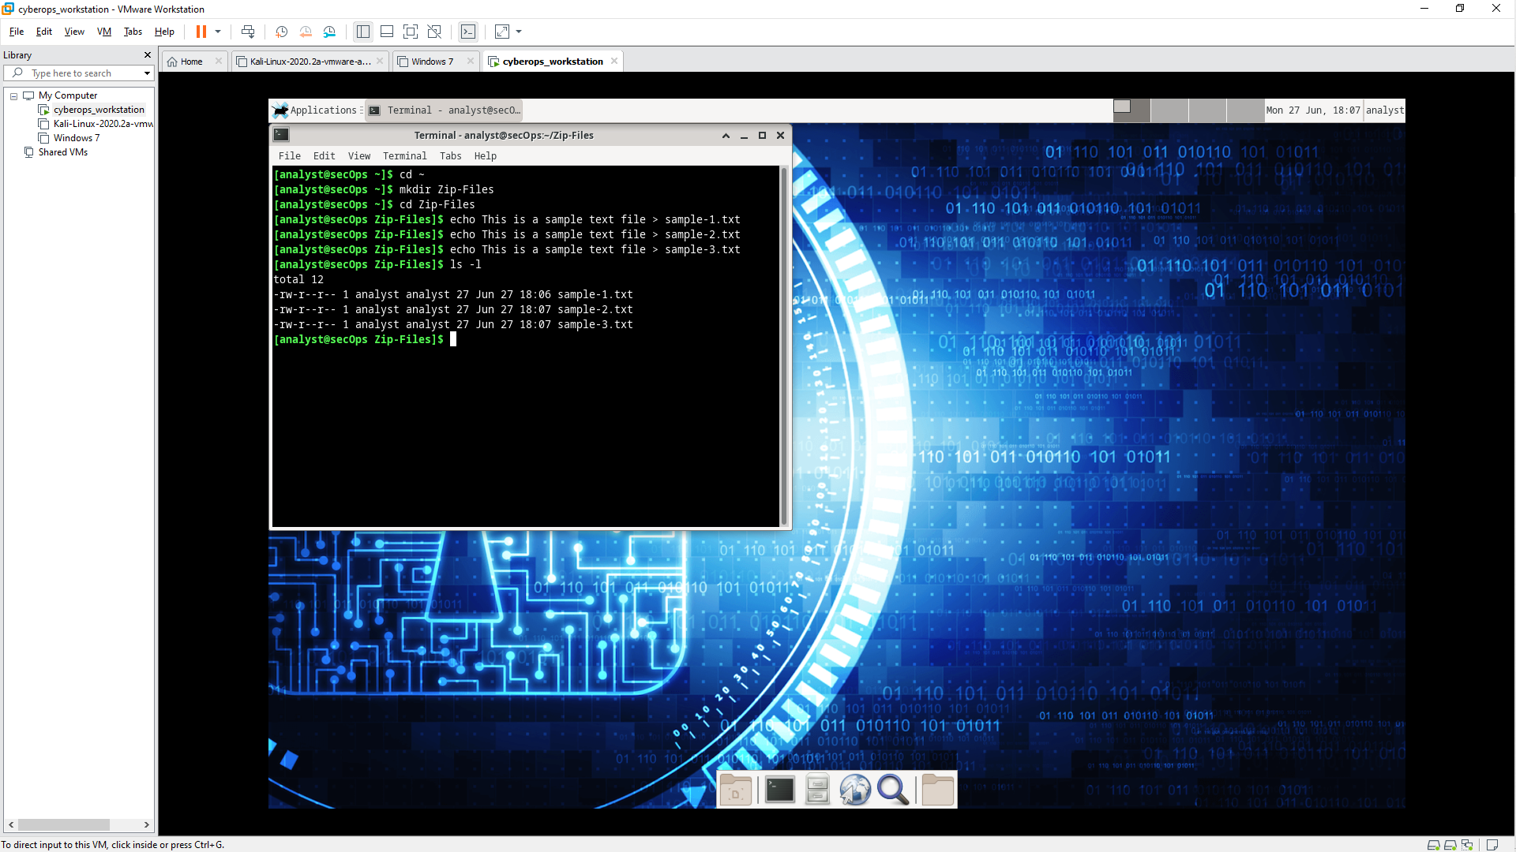

Step 2: Zip and encrypt the text files.

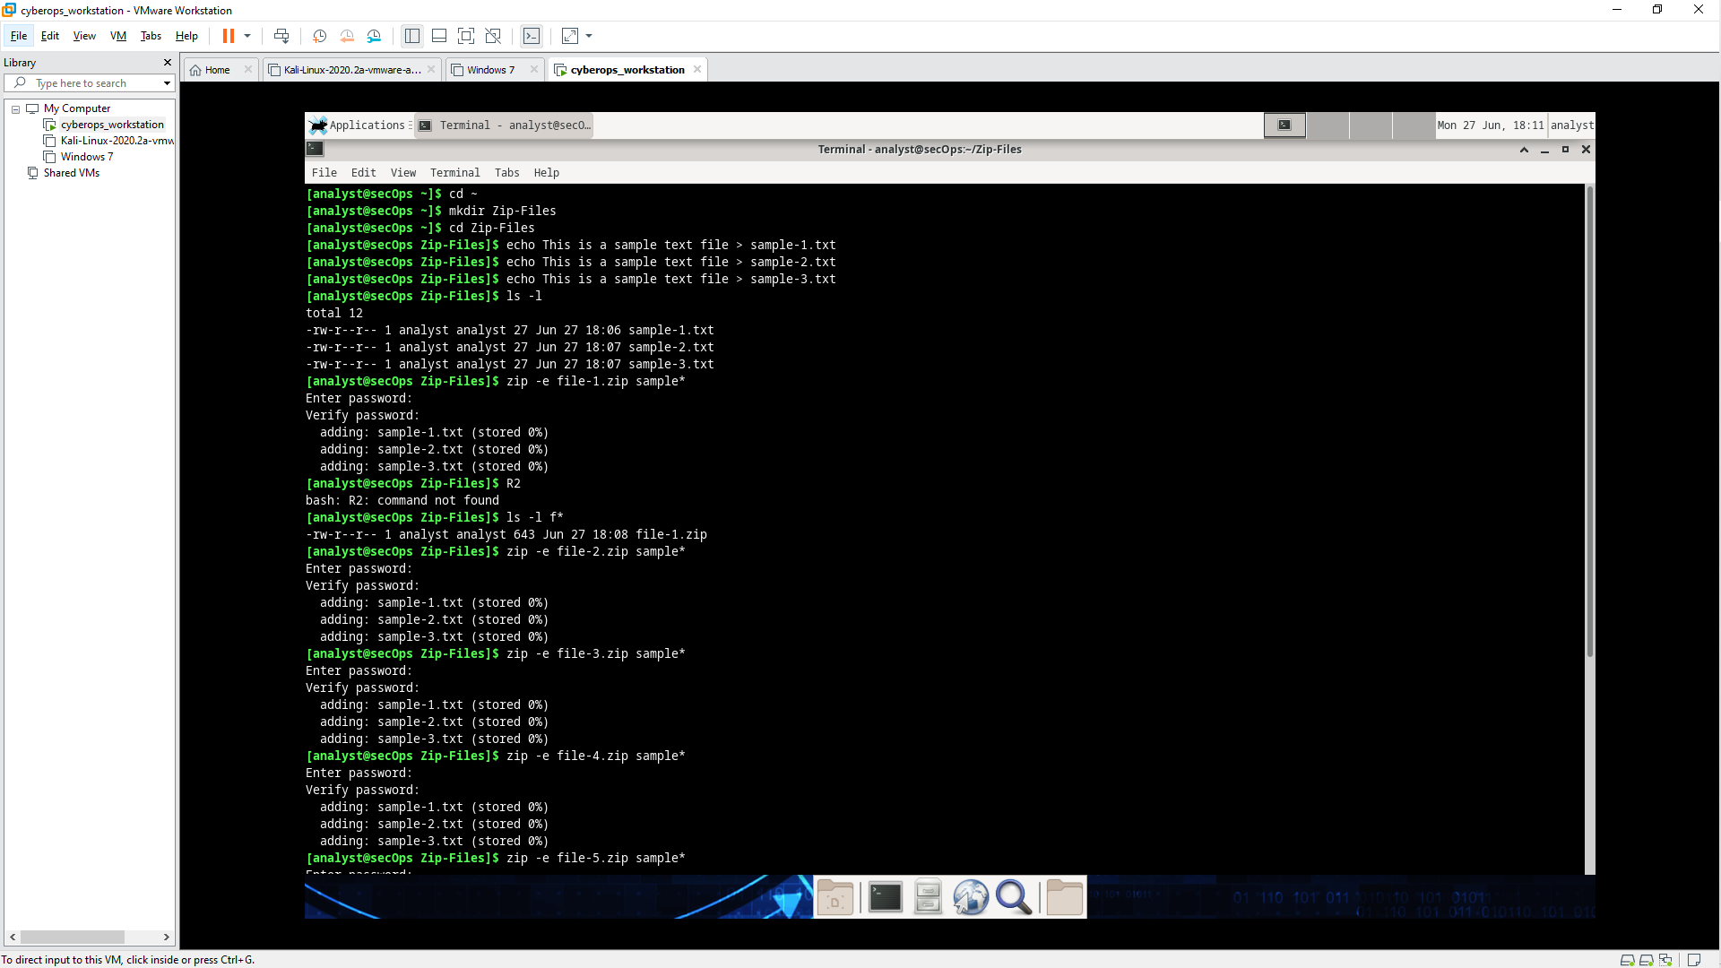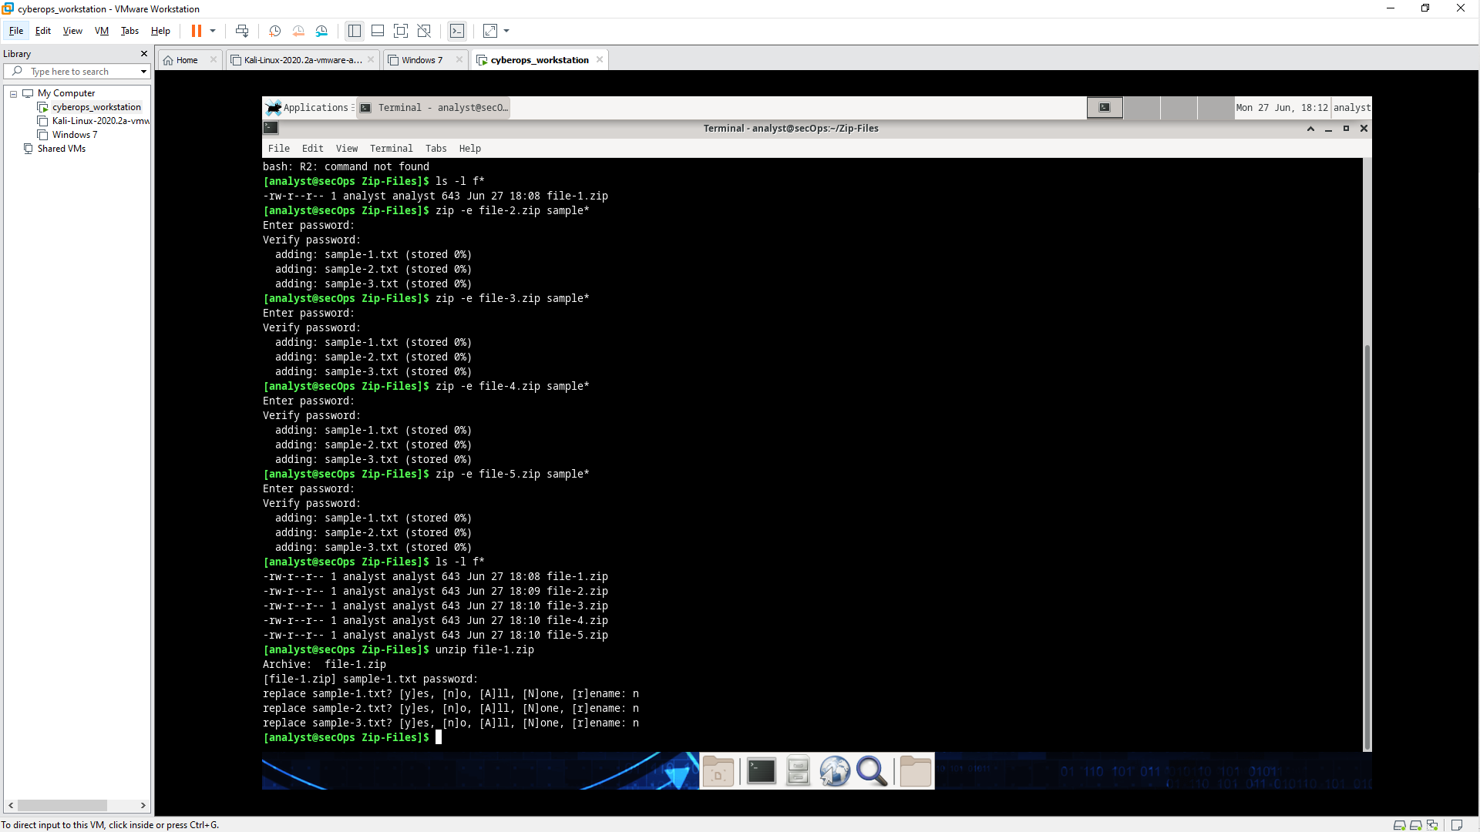

Part 2: Recover Encrypted Zip File Passwords

Step 1: Introduction to fcrackzip

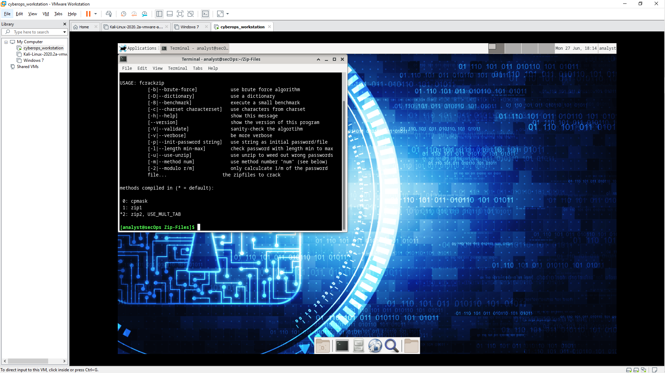

Step 2: Recovering Passwords using fcrackzip

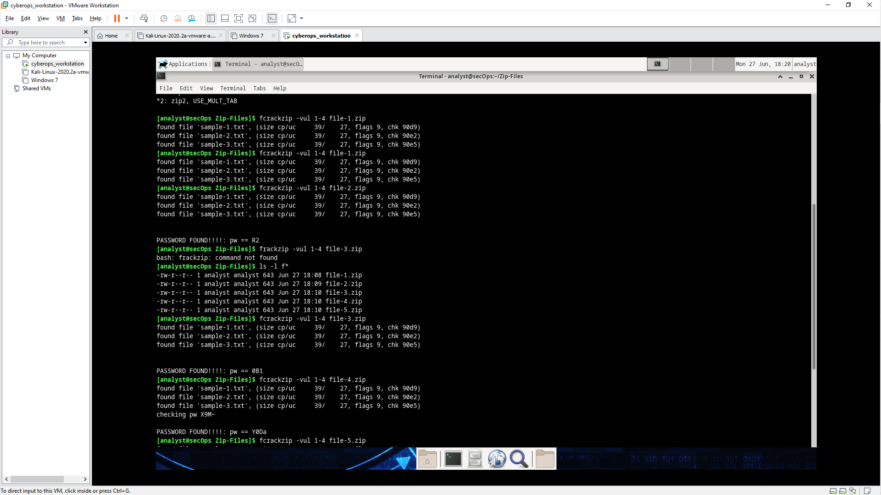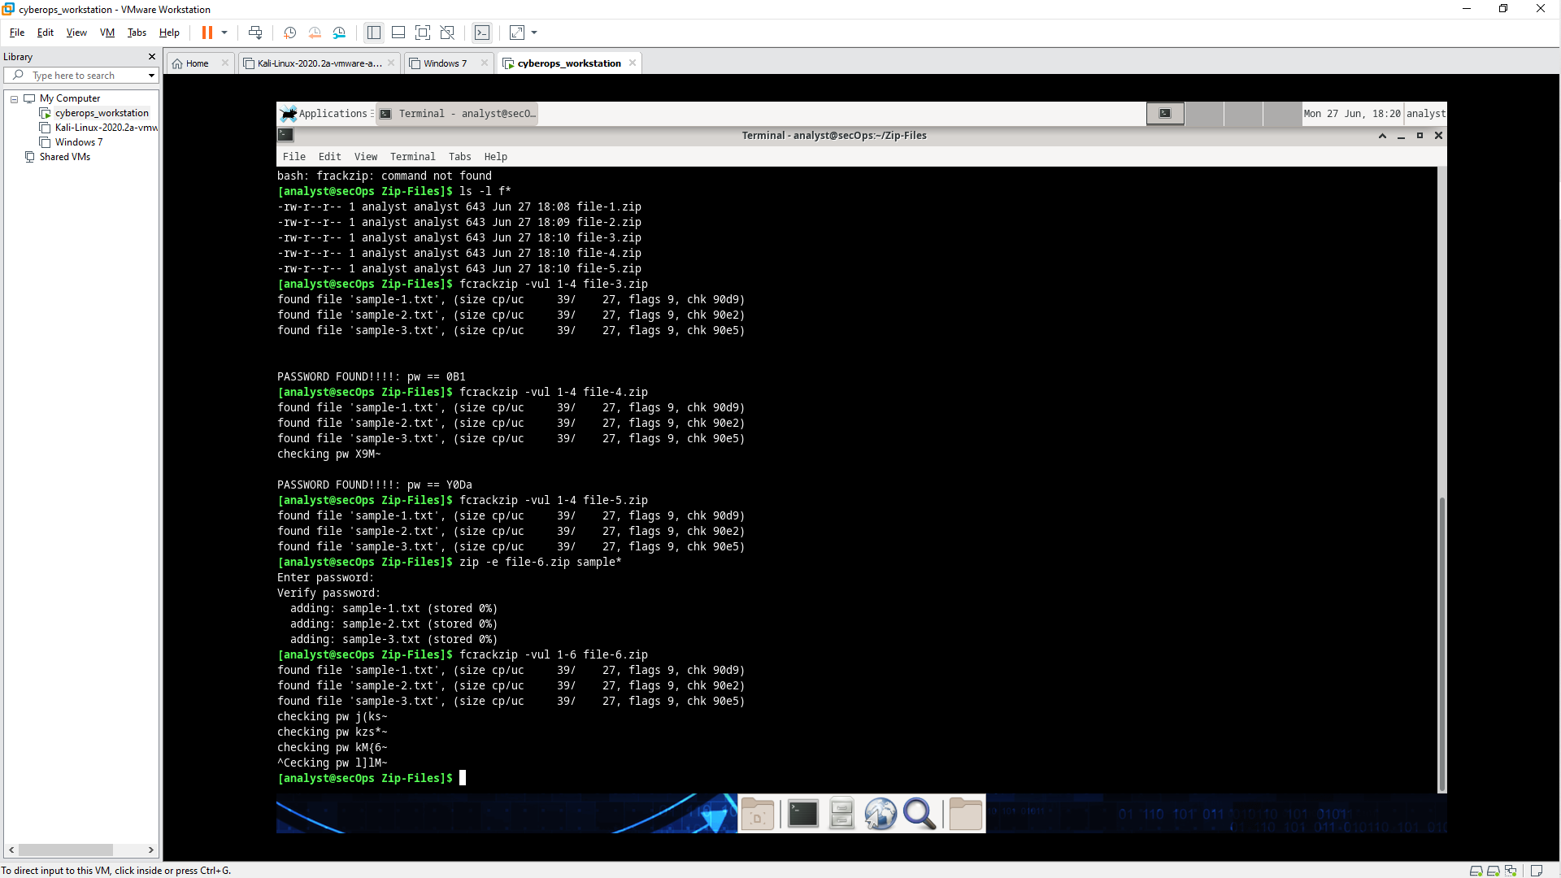

a) How long does it take to discover the password? – Fast

b) How long does it take to discover the password? – Fast

c) How long does it take to discover the password? – Fast

d) How long does it take to discover the password? – Fast

e) How long does it take to discover the password? – Fast

f) How long does it take to discover the password? – Fast

g) How long does it take fcrackzip to discover the password? – Slow

How long would you recommend a password needs to be for it to be secure? – 1 day